Statistical Analysis using Data Mining: A District Level Analysis of Malnutrition

Reyhan Gupta
Department of CSE, ASET
Amity University
Noida, Uttar Pradesh, India
reyhangupta@gmail.com
Gaurav Raj
Assistant Professor, Department of CSE, ASET
Amity University
Noida, Uttar Pradesh, India
graj@amity.edu

Abstract— Children in India suffer from the highest level of undernourishment in the world, having serious effects on health. Bihar in turn has the highest incidence in India. This study was taken up to ascertain the effect of clusterization on a large data set with respect to analyses the association of multitude of variables with malnutrition indices. Raw data was obtained using Secondary data sources, especially Government reports, pertaining to malnutrition indices, demographic, social, nutritional, economic and medical factors causing malnutrition. In stage one the variables from non-clustered data was correlated with malnutrition indices (Stunting, wasting and underweight). Subsequently the data was split using Rapid Miner Studio into three clusters. This segregation was done by the software using k-means and Hierarchical agglomerative clustering. In the second phase each of these clusters were again analyzed using the software and the correlation results were compared. Significant variation was observed in most of the correlations in the clustered and un-clustered data sets. This indicates the importance of clusterization in reaching the truth when a statistical analysis is carried out, as clusterization excludes/segregates the outliers / extremes of values. This has significant implications in policy making for malnutrition control, through identifying the most relevant variables/factors responsible.
Keywords—clustering, malnutrition analysis, data analysis, data mining

Introduction
As per the World Bank Report, 2015, India fares very poorly in Global Hunger Index. India scores 29 points and its malnutrition condition is stated as ‘serious’, as it is ranked even below Bangladesh, Sri Lanka and Sub-Saharan Africa. Bihar lies at the bottom of Malnutrition table in India, with child undernourishment rates to be as high as 80 percent. [1] Though several polices have been initiated to address malnutrition in the state, it seems either the schemes presently running in the state are not reaching the beneficiaries or they are flawed. It is also possible that the policies for malnutrition control are not based on sound presumptions, which are meant to be dependent and, are as good as, relevant data generation, analysis, interpretation and application. [2] The latest NFHS 4 data released by the Government of India in 2017, gives the district level details of many determinants of Malnutrition in Bihar. [3] A maze of factors, ranging from poverty, economic status of family, medical condition of child, infections, nutritional status of women/mothers, demographic and social factors (literacy, female literacy), political will, to poor implementation of food-policies qualify as determinants of malnutrition. The relative importance of these determinants, is critical in selecting them to be targeted for effective malnutrition control.
Here lies the importance of efficient data mining which could delineate the most important undernutrition-determinants in a given district (or set of districts with similar social/demographic/medical attributes). Once such a set/cluster of similarly placed districts is segregated, it is easy to analyze it further with respect to the most critical determinants prevalent as a cause of undernutrition in that district/cluster. Since there are infinite permutations and combinations possible within these clusters, it is not humanly possible to pick the right ones up and process it. Data mining tools enable us to perform this cluster analysis so as to focus on the most important determinants and to prioritize them for selective policy making and intervention.

Literature survey

Data Mining

Data Mining is a field which helps us to find unknown patterns in data which may otherwise seem incoherent. The data mining methods that are being used are clustering, regression, association, classification, followed by statistical analysis. [4]

Clustering
Clustering is a technique to group different parameters based on the similarities that exist between them and their interrelationship with each other. It enables us to understand how data is distributed and to understand the similar and dissimilar objects in the data. The important techniques for clusterization are Centroid Based, Hierarchical, Distributed, and Density based Clustering. For this paper the K-means Clustering algorithm and Hierarchical Agglomerative clustering were implemented which are partition and hierarchical algorithms respectively [5].
According to the k means algorithm, if we have a data set having n objects, we can partition it into k different partitions (or clusters) such that k ≤ n. We make sure that each data point gets associated with a cluster. [6] The optimal value of k can be determined by the smallest Davies Bouldin index and lesser the DB index, more accurate the value of k. [7] The K-means algorithm follows the following pseudo code
Set a_{i}…a_{k} be distinct randomly selected inputs from x_{i} … x_{k}
repeat
for i=1…n do
y_{i j} = 1 if j = argmin _{j} ²
y_{i j} = 0 otherwise
end for
for j=1…k do
n_{j} =
a_{j} =
end for : until convergence
Return a₁ … a_{k}
The following expression is used during analysis of k means:
J = ²
Where J=Objective function, k= number of clusters, n= number of cases, c_{j} = centroid for cluster j, x= case number

The Hierarchical agglomerative algorithm was also applied on the data set to compare and contrast the results obtained with k-means. It uses a bottom up approach which leads to the creation of sub clusters and repeatedly creates more of these. Clusters are generated using the following steps:
1) Each object is assigned to a separate cluster.
2) Distances between various clusters formed is evaluated
3) A distance matrix is then created using the values obtained.
4) The clusters with the shortest distance between them are selected and removed from the matrix.
5) These are then merged into a single cluster.
6) The above process is repeated till the matrix is left with a single element and further comparisons are not possible.

C) Davies Bouldin Index
The K means algorithm can be implemented for varying degrees of clusters expressed by k. The optimal value of K can be found by considering the lowest Davies Bouldin Index which can be found using the expression shown hereunder:
DB =
Here, the count of clusters is shown by N, Di is the cluster distance ration such that average distance between points and its centroid in that cluster, for all the clusters in the data set.

Methodology
Scope of Study: The present work is an in depth district level exploratory analysis where information has been gathered applying the 'Secondary data collection' approach. The data pertained to all the 38 districts of Bihar. Twenty seven potential determinants of malnutrition of economic, health, medical, social and demographic categories were shortlisted and studied.

Steps Involved
No
Yes
Visit NFHS4 website, Census India website, RCOS and various Economic Surveys

Compile the data in an Excel File
Import data into Rapid Miner Studio

Perform k-means clustering
Data Inconsistent?

Perform Correlation Analysis

Clean Data
Minimum DB Index?

No
Yes

Figure 1: Flowchart showing steps involved
1) Obtaining the Data: The primary source for social and medical data was NFHS4, of 2017 Government of India (GoI). The demographic data was derived from Census 2011 and economic data from Economic Survey of GoI.[3]
2) Data Cleaning: Data was cleaned and prepared before analysis. The missing entries were replaced with averages. Columns with no significance to the study were removed. All values were brought to percentage form for uniformity
3) Importing Data: Data was imported in as an Excel file and saved in the Local Repository of the Rapid Miner Studio.
4) K means Clustering Algorithm: The data was then divided into clusters by using the k-means clustering algorithm.
5) Hierarchical Agglomerative Algorithm: The same data was run through the Hierarchical Agglomerative algorithm to compare the results with that of k-means, and selecting the most suitable approach.
6) Davies Bouldin Index: The optimal value of k was found by considering the smallest Davies Bouldin Index value.
7) Correlation Analysis: Correlation is found using Pearson’s correlation coefficient to determine how strongly the values are correlated with dependent variables. [8]

Experimental Setup
The Dependent variables for the study were Malnutrition indicators, i.e., Stunting, Wasting, Severe Wasting and
Underweight. These were analyzed against the independent
and Health Services related factors. The important parameters have been described in Table 1. Correlation of these with the dependent variables would determine which parameters were prominent in which districts and to pinpoint these for improved policy making and better knowledge of the same.
Parameter | Definition | Parameter | Definition
Electricity% | Percentage of villages with electricity | Exclusive breastfed % | Infants fed only breast milk till 6 months of age
Water source % | Percentage of villages with clean water source | Full ANC visits % | Women who visited Dr 4 times for check-up and took TT, Iron tablets during pregnancy
Sanitation  % | Percentage of villages with toilets at home | Full immunization  % | Children receiving full course of vaccination
Clean fuel  % | Percentage  Of Villages  With clean fuel | Women BMI <18.5  % | Women with BMI<18.5, (malnourished)
Female Literacy  % | Women who could read/ write(Census) | Women anemic  % | Women with Haemoglobin <10g%
Anemia Children  % | Children with Haemoglobin <10g% | Women married before 18 % | Women aged 19 to 45 years of age, married before age of 18 years
Women 10th class % | Women who had passed Class 10th or more | Adequate diet  % | Infants getting adequate diet
Colostrum  % | New-borns given the first breast milk | Sex Ratio  % | Number of women per 1000 men in the district
Under-weight % | Children falling below standards for weight for age criteria | Severely Under-weight  % | Children falling below standards for weight for age criteria (<3SD)
Wasted % | Children falling below standards for Weight for height (<2SD) | Severely wasted  % | Children falling below standards for Weight for height criteria(<3SD)
Stunted  % | Children falling below standards for height for age (<2SD) | Severely Stunted  % | Children falling below standards for height for age criteria(<3SD)

Model Structure
Rapid Miner was used for analyzing the data, running clustering and correlation algorithms and to generate results.

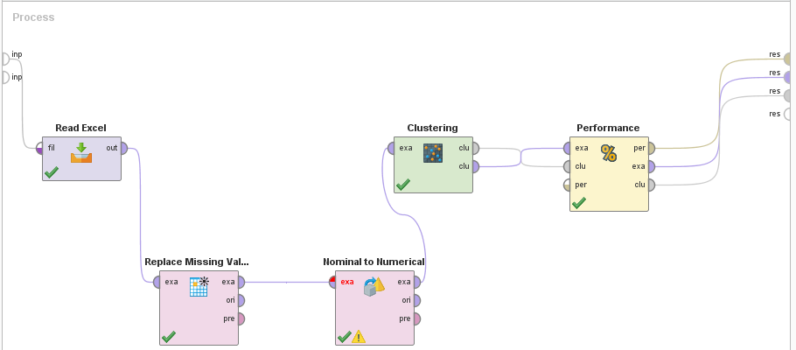
Figure 2: Model used in Rapid Miner for running k means.

The model structures used in Rapid Miner Studio for bringing forth the clusters are shown in Figure 2 and 3. The excel data sheet was imported and saved in the local repository. It was passed through a Replace Missing Value attribute where the data fields with no values were replaced with averages.
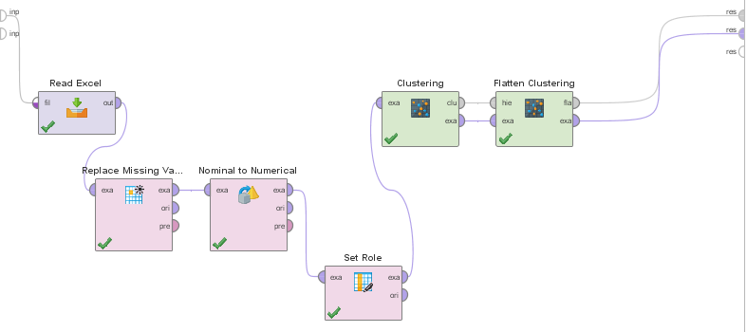
Figure 3: Model used in Rapid Miner for Agglomerative Algorithm.

This data was then plugged into a Nominal to Numerical Filter. This was carried out as the data set comprised of alphanumeric and numeric entries and the algorithm was not able to work on such datasets.
After cleaning and preparing the data, the K means algorithm was applied to the dataset using the k-means operator. The results generated were fed into a Cluster Distance Performance Operator to analyze the cluster with respect to the centroid distance, DB index, etc. for a clearer understanding of clusterization. [9]
The data set was then passed through an agglomerative algorithm. Flattening of clusters was used to limit the number of clusters and a complete link mode was implemented. To find the optimal k value, the algorithm was run for different k values and the DB index was noted afterwards. The optimal value of k was selected for the point at which the Davies Bouldin Index is minimum. As seen in table 2, the value is 3.
Table 1: Attributes of Dataset. (The determinants of malnutrition have been highlighted in green, and we try to find out how the other independent factors (shown in white) affect them.)

Table 2: - Optimal Davies Bouldin Index (shown in green)
K=3 | K=4 | K=5 | K=6 | K=10
DB  Index=  -0.303 | DB  Index=  -0.399 | DB  Index=  -0.457 | DB  Index=  -0.350 | DB  Index=  -0.387

Result and analsis

Clusterization
K-means was implemented on the data set with k=3 giving optimal Davies Bouldin Index
The Hierarchical Agglomerative algorithm was also used, with the flattening value set at 3. It was found that this approach yielded the same results as k-means. Hence we can conclude that the clusterization was carried out in an accurate manner. In this paper the k-means algorithm was used for further analysis because it has advantages over the other, which include better performance and reduced execution time. [10]
Since the data set contains a multitude of variables, with widely varying figures over a large magnitude, the conventional analysis of this data set as a whole, may give fallacious results. For example, certain extreme values (very low or very high) which are present as outliers do not give the correct interpretation on analysis. It is therefore vital to segregate the dataset into clusters with similar attributes, for more meaningful analysis. [11] Rapid Miner was used to make clusters, applying K Means and the agglomerative algorithm.
The clusters obtained in this data set are as shown in Table 3:
Table 3: Clusters and corresponding number of objects
Cluster Number | Objects:- (Districts}
Cluster 1 | 1 District:- (Patna)
Cluster 2 | 5 Districts:- (Begusarai, Bhagalpur, Munger, Muzzafarpur, Rohtas)
Cluster 3 | 30 Districts:- (Remaining 30 districts, mentioned at the end)
 | Total = 36 districts

To observe the relevance of results after clusterization, a baseline analysis was carried out on original data prior to clusterization as well. Results have been tabulated in Table 4.

Correlations
Correlations were worked out between the Dependent variables (i.e. the malnutrition indicators, namely Stunting, Wasting, Severe Wasting and Underweight with the independent variables namely Demographic, Education, Mother/Child Health and Health Services related factors.
The results of statistical analysis, using Rapid Miner are summarized in the subsequent tables. Table 4 depicts results before clusterization, from the original data involving all 36 districts of Bihar.

Capability Deprivation  Indicator | Stunting  (r value) | Wasting  (r value) | Severe Wasting  (r value) | Under-weight (r value)
Demographic  ~Sex ratio  ~Women married <18 yrs. | -0.34  0.48 | -0.20  0.06 | -0.10  -0.04 | -0.37  0.32
Education  ~Female literacy  ~Women studied till 10th | -0.31  -0.28 | 0.17  -0.23 | 0.15  0.22 | -0.12  -0.09
Mother's Health ~Malnourishment (BMI<18.5)  ~ Anaemia | -0.49  0.09 | 0.21  0.24 | 0.90  0.12 | 0.51  0.23
Child Health  ~Diarrhoea  ~ ARI | -0.14  -0.31 | -0.53  -0.37 | 0.42  -0.35 | -0.44  -0.41
Health Services  ~ AWW  ~ ASHA | 0.157  0.170 | -0.28  -0.160 | -0.20  -0.003 | -0.07  0.08
Utilization of Health Services  ~ANC  ~ 4 ANC Visits  ~Immunization | -0.43  -0.41  0.26 | -0.10  0.11  0.25 | -0.09  0.13  0.31 | -0.37  -0.25  0.21
Child Feeding  ~Breastfed in 1 hr  ~Exclusive breast Feeding  ~Colostrum fed  ~Adequate diet | 0.33  -0.30  0.075  0.037 | 0.16  -0.28  0.14  -0.15 | 0.034  -0.17  -0.01  -0.17 | 0.30  -0.39  0.23  0.01
Table 4: Correlations before Clusterization (36 Districts)

Data is segregated into clusters with the aim of finding trends in the data set, and the results are depicted in Tables 5 and 6.
Cluster 1: District Patna, the most urban, economically and socially developed district of Bihar was found to be an outlier with significantly differing parameters as compared to other districts. Hence it was segregated as just one object in that cluster, so no correlations were possible and no tables could be drawn for it and was therefore couldn’t be analyzed further.

Cluster 2: This cluster contained 5 districts. Attributes are summarized in Table 5
Capability Deprivation  Indicator | Stunting  (r value) | Wasting  (r value) | Severe Wasting  (r value) | Under-weight (r value)
Demographic  ~Sex ratio | -0.54 | -0.55 | -0.11 | -0.86
Economic  ~Per capita income  ~Ruralisation | -0.55  0.53 | -0.30  -0.64 | -0.3  0.02 | -0.13  0.04
Mother's Health  ~Anaemia | -0.19 | 0.74 | 0.24 | 0.30
Child Health  ~ARI  ~Anaemia | 0.35  -0.36 | -0.59  0.85 | -0.52  0.83 | 0.05  -0.37
Health Services  ~ AWW  ~ ASHA | -0.32  0.25 | -0.26  -0.74 | 0.06  -0.13 | -0.75  0.08
Utilization of Health Services  ~ANC | -0.34 | 0.08 | 0.25 | -0.15
Child Feeding  ~Breastfed in 1hr  ~Colostrum fed  ~Adequate diet | -0.30  0.89  -0.30 | 0.05  -0.43  0.26 | -0.26  -0.30  -0.31 | -0.39  0.82  -0.16
Health Facilities  ~Water  ~Sanitation | 0.184  -0.90 | -0.53  0.31 | 0.23  -0.15 | -0.26  -0.64
Table 5: Primary: Basic Malnutrition Outcome-Dependent Variables

Cluster 3: This cluster contained 30 districts/objects. Attributes are summarized in Table 6.
Capability Deprivation  Indicator | Stunting  (r value) | Wasting  (r value) | Severe Wasting  (r value) | Under-weight (r value)
Demographic  ~Sex ratio  ~Female literacy  ~Women 10thpass  ~Woman married <18 years | -0.32  -0.22  -0.22  0.54 | -0.32  0.14  0.10  0.12 | -0.21  0.17  0.18  0.01 | 0.28  -0.17  -0.13  0.15
Economic  ~Per capita income  ~BPL | -0.28  0.09 | -0.01  0.35 | -0.04  0.28 | -0.06  -0.32
Mother's Health  ~Anaemia  ~Diarrhoea  ~Women BMI <18.5 | 0.09  -0.24  0.46 | 0.26  -0.54  0.36 | 0.17  -0.41  0.17 | -0.16  0.30  -0.10
Child Health  ~Anaemia | -0.01 | -0.04 | 0.21 | 0.12
Availability of Health Services  ~AWW  ~ASHA | 0.16  0.02 | -0.28  0.03 | -0.24  0.20 | 0.20  -0.24
Child Feeding  ~Exclusive Breast Feeding | -0.44 | -0.28 | -0.15 | -0.04
Health Facilities  ~Water  ~Clean Fuel | 0.07  -0.32 | -0.45  -0.22 | -0.27  -0.20 | 0.14  0.20
Table 6: Basic Malnutrition Outcome (Cluster 3)

Discussion
If the entire data collected is analyzed as a whole, as one data set containing many variables, with numbers and figures varying over large magnitude, it may end up with erroneous results. For example, certain extreme values (very low or very high) which are present as outliers do not give the correct interpretation. It is therefore very important to segregate the dataset into clusters with relatively similar attributes, for reaching closer to truth through meaningful analysis.

Inter cluster analysis
The data analysis has been oriented to appreciate this effect. It was therefore decided to compare the correlations obtained in the original information set and the three clusters generated, based on common attributes. This inter-cluster analysis helps the researcher to get a more real effect of different independent variables on the malnutrition indicators.
The effect of inter-cluster analysis is shown in Figure 4. It is observed that for many attributes there are wide variations in the correlations obtained for the original (non-clustered) data set and the two other clusters. For example, the correlation between Sanitation and severe wasting varies starkly for un-clustered data (minimal at r = - 0.19) and for clusters 2 and 3 at r = - 0.90 and r = – 0.05, respectively. This indicates that, had we been interpreting this data merely using the traditional system of analyzing the non-clustered original data, we would have found poor correlation between Sanitation and malnutrition as the Pearson’s Correlation Coefficient is found to only at – 0.19). This indicates that there is negligible association between sanitation and malnutrition in children.

Cluster with Districts | Parameters to be targeted
Cluster 1  (Patna) | Patna, the most urban, economically and socially developed district of Bihar was found to be an outlier with no specific parameters to target.
Cluster 2  (Begusarai, Bhagalpur, Munger, Muzzafarpur, Rohtas) | Improving Sanitation and Water source, Adequate diet to infant, Acute Respiratory problems, Maintaining a balance of sex ratio, Preventing anemia in women and children, Increasing Anganwadi workers’ presence and contribution.
Cluster 3 (Araria,Arwal,Aurangabad, Purb, Banka, Bhojpur, Buxer, Siwan, Darbhanga, Gaya, Gopalganj, Jamui, Jehanabad, Kaimur, , Kathiar, Khagaria,Kishanganj  Lahisarai, Madhenpura, Sitamarhi Madhubani, Nalanda, Nawada Pash, Champaran, , Champaran, Purnia, Saharsa, Samastipur, Saran, , Sheohar, Sheikhpura) | Improving Clean fuel availability, water facilities, breastfeeding to be continued for at least the first six months of infant’s birth for better health, curbing diarrhoea, providing Adequate diet for women and awareness should be spread for women to get married only after 18.
Table 7: Parameters to target for curbing malnutrition in Bihar.

But when the data is segregated into three clusters, the results are starkly different. The 1st cluster of one district (Patna),which had extreme values has been left-out of analysis as it will vitiate the results and give fallacious interpretations. The other two clusters have been defined by the software using certain common attributes. Thus the remaining 35 districts (excluding Patna), have been segregated into 2 clusters of five and thirty districts. Here the results are totally different. The second cluster of five districts gives a very good Pearson’s correlation coefficient of r = - 0.90. This indicates a very strong association between sanitation and malnutrition.
The third cluster however shows a result with correlation at r = -0.05. Hence there is a negligible correlation for the same- between sanitation and malnutrition.
These varying correlation values have major implications on the prevention and control of malnutrition. In case the correlations are found to be ‘strong’ it indicates that measures are required to be taken against that independent variable (sanitation), and if there is poor/no correlation then the relative importance of that determinant is negligible and it doesn’t really need a modification, in order to control malnutrition. To illustrate the present example, there was a minimal correlation seen between sanitation and malnutrition when the entire (un-clustered) data was analyzed (r= - 0.19).
This indicates that since sanitation has minimal effect on malnutrition, no measures are required to be taken to improve malnutrition in the State of Bihar. However when Cluster 2 was analyzed, it indicated a correlation coefficient of –0.90, depicting a very strong association, thus highlighting the undisputed importance of sanitation in this Cluster 2.

Hence it is imperative that all measures must be taken to improve sanitation in this cluster of districts, in order to improve malnutrition. On the other hand in cluster 3, where the r value was found to be minimal, probably that much emphasis on sanitation is not needed.
It is inferred from the above discussion that clusterization not only orients the data analysis in the correct direction, but also helps in the most prudent data interpretation, as it is seen in the instant case that the correct data interpretation would lead to correct policy making, for malnutrition control.
Different parameters have thus been identified from the analysis above, and special emphasis can be given to these specifically instead of targeting all and giving them equal importance, which has not been very successful up till now. Table 7 mentions the clusters, districts in them and the parameters to target for curbing malnutrition in Bihar.

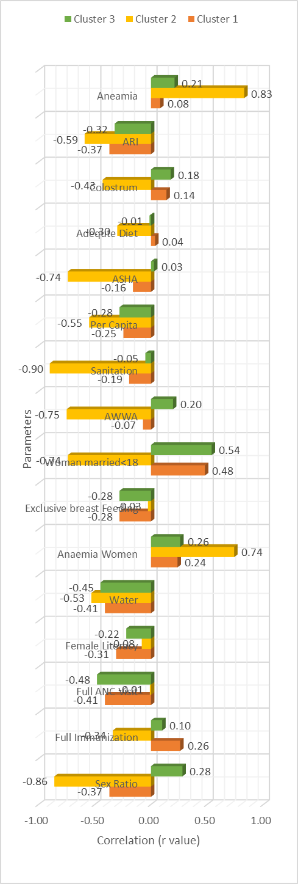

Conclusion
The purpose of data collection and its statistical analysis is to reach closest to the truth. Analysis of the big data set as a whole has the limitation of having extremes in the data, which produces fallacious results on analysis, thus deviating from the truth. Clustering of data into smaller groups based on common attributes and their subsequent analysis helps overcome this limitation. In the present study clustering enabled us to understand the real correlations between various independent variables and malnutrition. This would help the policy makers’ to shortlist the most appropriate factors contributing to malnutrition and take corrective action. This technique of data mining is unique and most appropriate in the given setting.
Conflict of Interest: Nil

References
[1] Report of the Comptroller Auditor General on Performance audit of ICDS. Report No. 22, 2012-13. Delhi
[2] Gupta A, Gupta SK, Baridylne n. Integrated Child Development Scheme (ICDS): A journey of 37 years. Indian J Community Health. Vol 25 (1) Jan-Mar 2013.
[3] National Family Health Survey 4, Government of India, Accessed on 20 March 2017.
[4] Anwesha Mal, Prof (Dr)Bebo White “Analysis and Clustering of PingER Network Data” IEEE Xplore Digital Library, DOI: 10.1109/CONFLUENCE, 2016
[5] Wagstaff, Kiri, et al. "Constrained k-means clustering with background knowledge." ICML. Vol. 1. 2001.
[6] Jyoti Yadav, Monika Sharma, “A Review of K-means Algorithm”, International Journal of Engineering Trends and Technology, Volume4, Issue 7-July.
[7] Jian Hua Yeh, Fei Jie Joung, Jia Chi Lin, “CDV Index: A Validity Index for Better Clustering Quality Measurement”, Journal of Computer and Communications, 2014.
[8] Chandan JS. Statistics for business and economics. Vikas Publishing House Pvt Ltd. New Delhi. 2003
[9] McCallum, Andrew, Kamal Nigam, and Lyle H. Ungar. "Efficient clustering of high-dimensional data sets with application to reference matching." International conference on Knowledge discovery and data mining. ACM, 2000
[10] Manpreet kaur, Usvir Kaur, “Comparison between K-mean and Hierarchical Algorithm Using Query Redirection”, Volume 3, Issue 7, July 2013
[11] Ngai, Eric WT, Li Xiu, and Dorothy CK Chau. "Application of data mining techniques in customer relationship management: A literature review and classification." Expert systems with applications (2009)

Figure 4: Inter-cluster Variability in Correlation Coefficients

